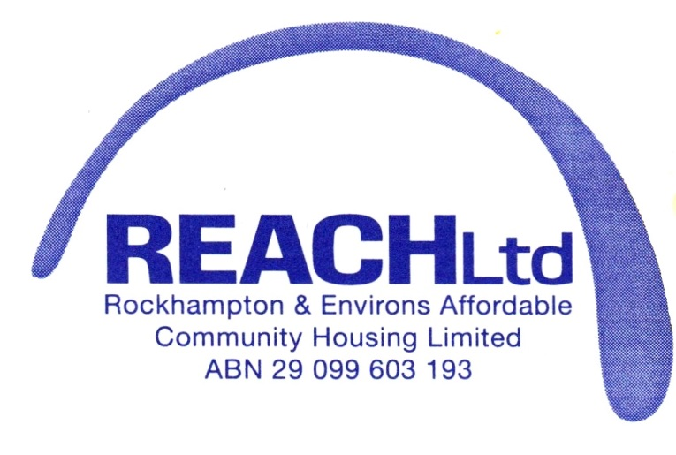

Risk Management Subcommittee
Charter
REACH Limited

Risk Management Subcommittee
- Introduction
This charter sets out the scope of the Risk Management Subcommittee in relation to the organisation.
The role of the Risk Management Subcommittee is not an executive role.
- Objective
The objective of the Risk Management Subcommittee is to assist the Board to maintain a comprehensive risk management system for identifying, assessing and managing risk with reasonable assurance in a rapidly changing environment; and
- Safeguard assets;
- Maintain appropriate standards regarding the environment and health and safety issues;
- Meet legal and regulatory obligations;
- Reinforce the values of the organisation by focusing on the needs of the organisation.
The Risk Management Committee is to:
Help the Board achieve its objectives in relation to:
- Business policies and practices;
- Legal and regulatory compliance;
- Internal control and risk management systems;
- Promote a culture of compliance;
- Ensure effective communication between the board, staff and when necessary stakeholders;
- Oversee the establishment and implementation of risk management and internal compliance and control systems and ensuring there is a mechanism for assessing the efficiency and effectiveness of those systems;
- Approve and recommend to the board adoption policies and procedures on risk oversight and management to establish an effective and efficient system for:
- Identifying, assessing, monitoring and managing risk; and
- Disclosing any material change to the risk profile (including ensuring that major risks are reported as deemed appropriate to the Chairman of REACH Limited.
- Regularly review and update the risk profile;
- Assess the adequacy of the internal risk control system with management;
- Ensure the risk management system takes into account all material risks, including risks arising from:
- Implementing strategies (strategic risk);
- Operations or external events (operational risk);
- Legal and regulatory compliance (legal risk);
- Changes in community expectation of the organisation’s behaviour (reputation risk);
Key Financial Risks
Assess and prioritise the areas of greatest potential financial risk, including:
- Safeguarding assets;
- Litigation and claims;
- Non-compliance with laws, regulations, standards and best practice guidelines that may result in significant financial loss;
- Maintenance of proper accounting records;
- Assessing the internal process for determining areas of greatest potential financial risk;
- Reporting to the board on the adequacy of the financial risk management;
Key Legal and regulatory risk
- Assess and prioritise the areas of greatest legal and regulatory risk;
- Assess the internal process for determining, monitoring and managing areas of greatest legal and regulatory risk;
- Monitor compliance with legal and regulatory obligations;
- Report and make recommendations to the board regarding:
- The management of areas of greatest legal and regulatory risk (including fraud and theft); and
- Compliance with legal and regulatory obligations.
- Receive and review reports in relation to compliance;

Other responsibilities
- Oversee the implementation of the REACH Limited code of conduct and assess compliance with it;
- If considered appropriate, investigate any complaint or allegation made to it;
- Report to the Board on any industry development affecting the control environment;
- Ensure that risk management and compliance policies and procedures are adequately documented and that those documents are reviewed and updated for any legal and regulatory developments.

The Risk Management Subcommittee must comprise of:
- At least one director (when available)
- The management team; and
- Where possible two other staff members.
The risk management subcommittee will appoint its chairperson and secretary. The chairperson must be an independent chairperson and may not be the chairperson of the board.
Each member of the risk management subcommittee should have an understanding of the organisation and its responsibilities to governing bodies.
Meetings
- Meetings will be held once a year to review the risk management plan and assessments. Additional meetings may be convened as required.
- Quorum for the risk management subcommittee is one staff member and the chairperson.
- Meetings may be held by any technological means allowing its members to participate in discussions even if all of them are not physically present in the same place. A member who is not physically present but participating by technological means is taken to be present.
- The risk management subcommittee may invite other persons it regards appropriate to attend the risk management meetings.

Minutes of Risk Management Subcommittee
- The risk management subcommittee must keep minutes of its meetings.
- Minutes of each risk management subcommittee meeting must be tabled at the next board meeting.
- Minutes, agenda and supporting papers are available to directors upon request to the secretary, except if there is a conflict of interest.
Access to information and independent advice
The risk management subcommittee may seek any information it considers necessary to fulfil its responsibilities.
The risk management subcommittee has access to:
- Management to seek explanations and information from; and
- Professional advice from appropriate external advisers, at the organisation’s cost.
Review and changes to this charter
The risk management subcommittee will review this charter annually or as often as it considers necessary. The REACH Limited Board of Directors may change this charter from time to time depending on the needs of the organisation.

Reviewed: May 2014
Reviewed: January 2020

